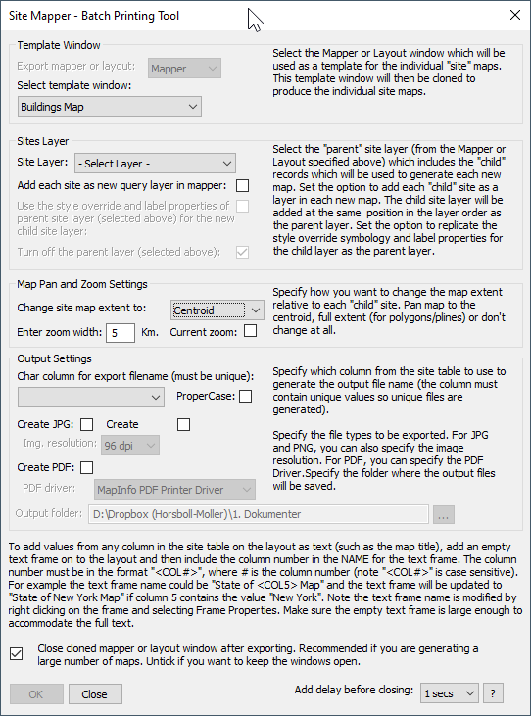

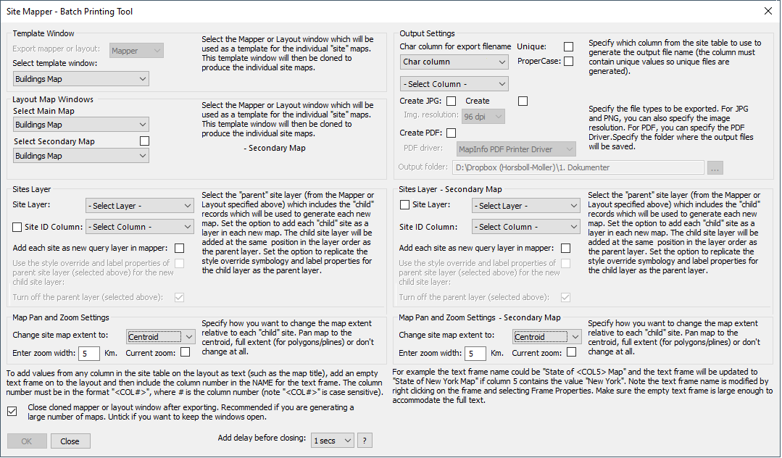

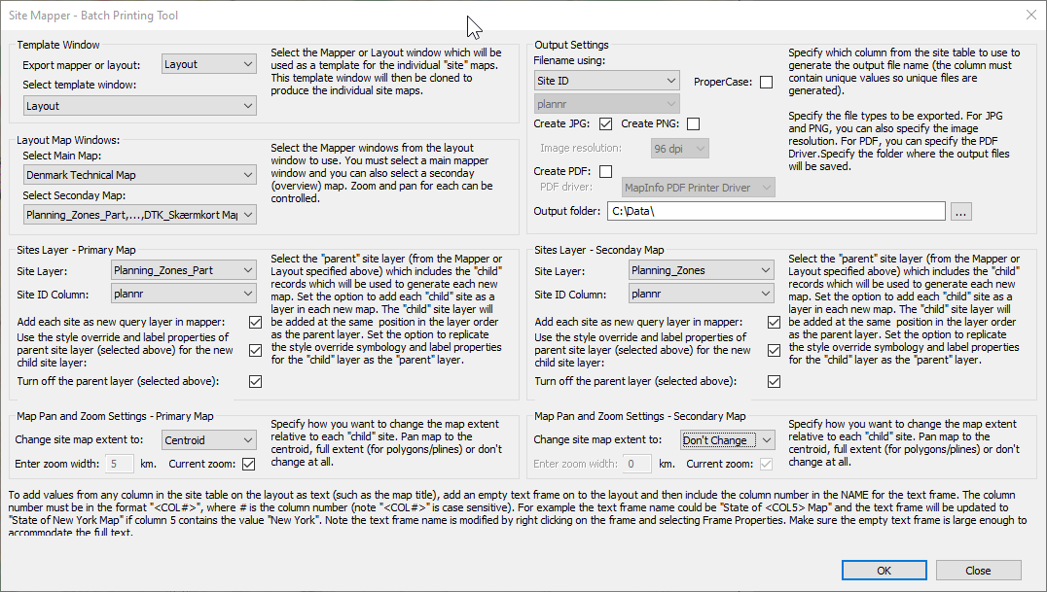

"Select the Mapper or Layout window which will be used as a template for the individual 'site' maps."

+ " This template window will then be used to produce the individual 'site' maps."

"Select the Mapper windows from the layout window to use."

+ " You must select a main mapper window and you can also select a secondary (overview) map."

+ " Zoom and pan for each can be controlled through the settings below."

"Select the 'parent' site layer (from the Mapper or Layout specified above) which includes the 'child' records"

+ " which will be used to generate each new map. Set the option to add each 'child' site as a layer in each new map."

+ " The 'child' site layer will be added at the same position in the layer order as the 'parent' layer."

+ " Set the option to replicate the style override symbology and label properties for"

+ " the 'child' layer as the 'parent' layer."

"Specify how you want to change the map extent relative to each 'child' site. Pan map to the centroid, full extent"

+ " (for polygons/polylines/multiple records) or don't change at all."

"Select the 'parent' site layer (from the 'Secondary Map' Frame specified above). This can be the same layer"

" as in the 'Primary Map' but it can also be a different layer. The values in the Site ID column of this"

" layer must be the same as in the primary site layer as they are used to filter out the 'child' records."

+ " The other settings are similar to the settings for the 'Primary Map'."

"To add values from any column in the site table on the layout as text (such as the map title), you can"

+ " use Smart Text in a text frame on to the layout. The Smart Text should be '$mb{SMGetColumnValue("City", 1, 0)}'"

+ " where ""City"" is the column name to read the value from, and '1' is the RowID in the 'child' layer, "

+ "typically you will use '1' for the RowID. You can combine the Smart Text with fixed text. The Smart Text will "

+ " return an empty string until Site Mapper starts processing the output. For a record with 'New York'"

+ " in column 'New York', the text 'City: $mb{SMGetColumnValue("City", 1, 0)}' would show as 'City: New York'"

+ " Make sure the text frame is large enough to accommodate the full text."

"Specify how to name the output files. This could be using a character column in the Site layer,”

+ " using the select Site ID column, or using a counter (the RowID) with prefixed '000's"

+ chr$(13)

+ "Specify the file types to be exported. For JPG and PNG, you can also specify the image resolution."

+ "For PDF, you can specify the PDF Driver."

+ "Specify the folder where the output files will be saved."